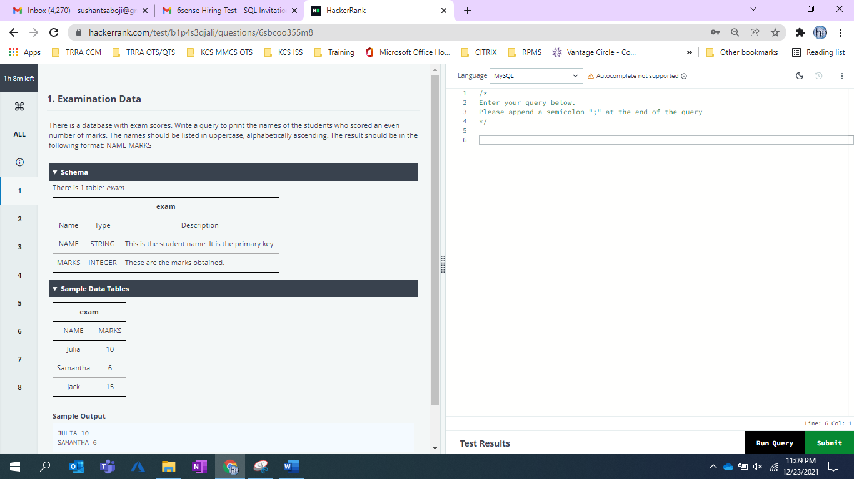

UPPER (NAME),marks from exam where marks %2=0 order by NAME  
  
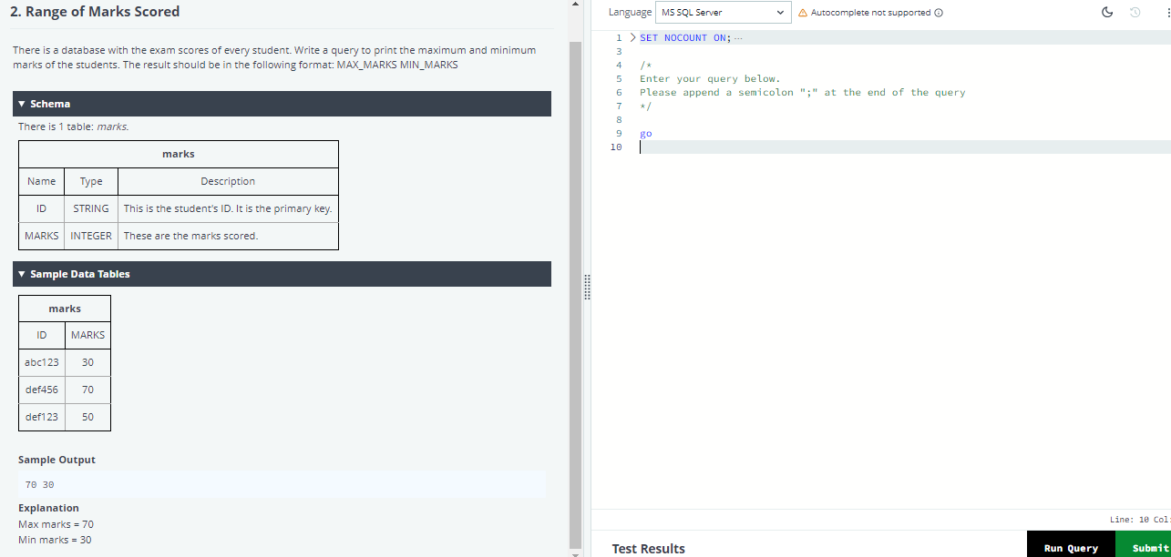  
  
select max(marks)as MAX_MARKS, min(marks) as MIN_MARKS from marks

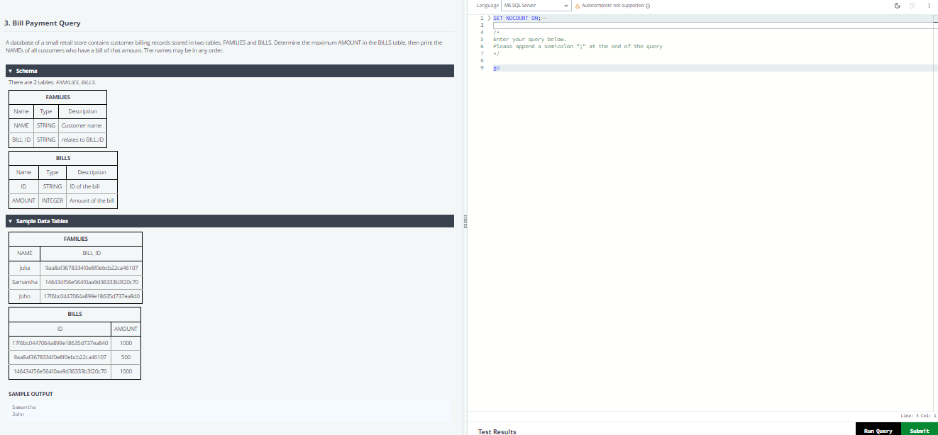

select F.Name , B.AMOUNT

from FAMILIES F

join BILLS B on B.ID = F.BILL ID

where B. AMOUNT = (select max(AMOUNT) from BILLS);

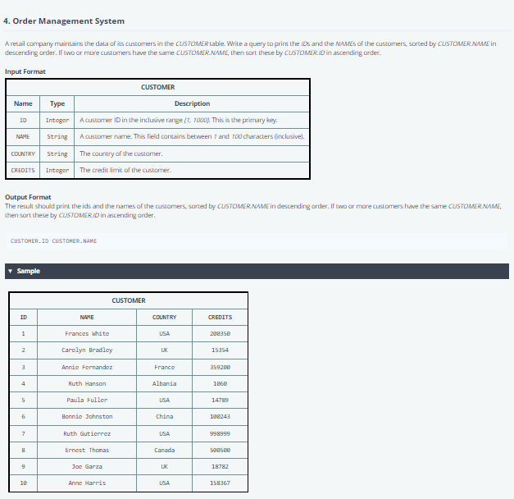

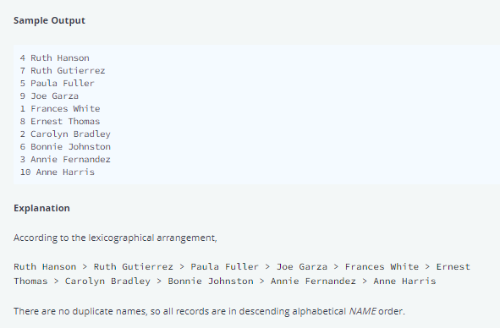

select ID,NAME from customer order by name desc,ID asc

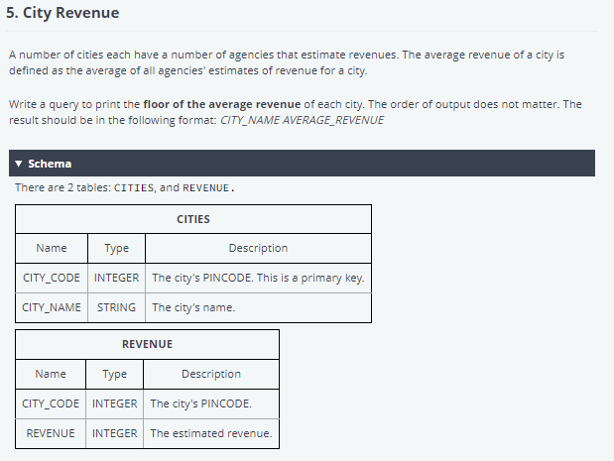

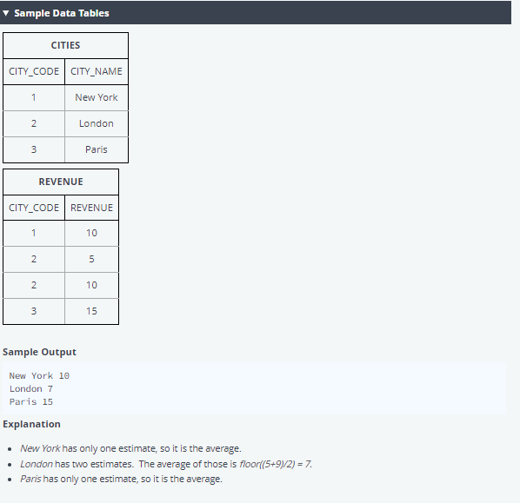

select C.CITY_NAME, avg(R.REVENUE) from CITIES C join REVENUE R on C.CITY_CODE = R. CITY_CODE

group by C.CITY_NAME

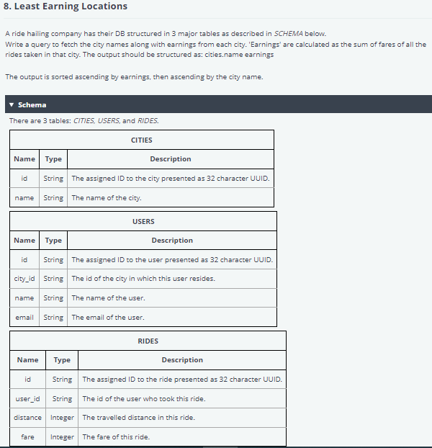

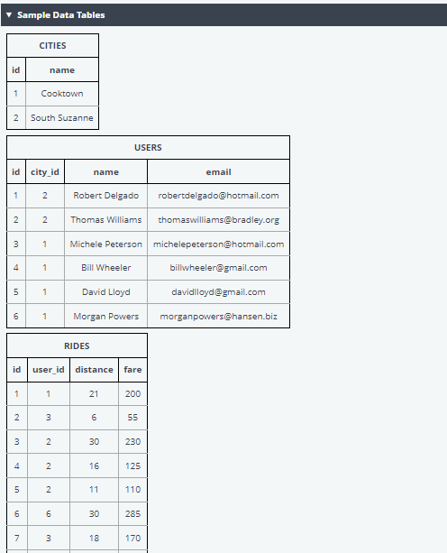

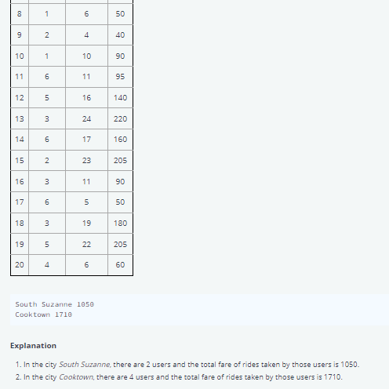

d'

rosy.jitin@aeratechnology.com